Task 5 : IoT Dashboard

Project Name: Hydroponic IoT Monitoring System

Wokwi

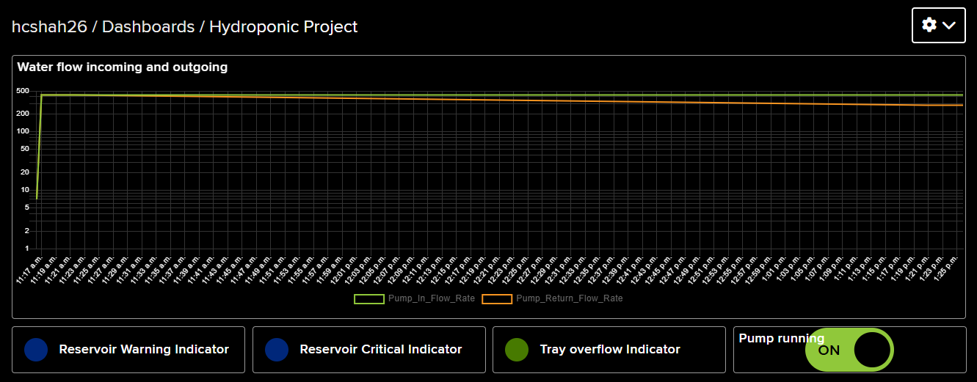

Adafruit IO - Dashboard

Author: Hiten Shah

Simulation Platform: Wokwi / Adafruit IO

# Contents

Contents

Contents 2

Dashboard Overview 3

Required Visualizations: 3

Alert System Implementation: 4

Dashboard Platform: 4

Appendix A – Adafruit IO 5

Appendix B - Feeds Page 6

Appendix C - Dashboard Page 7

Appendix D - Actions Page 8

Appendix E - Alerts Email 9

# Dashboard Overview

The IoT dashboard is designed to communicate sensor data in real time and provide a user-friendly interface for monitoring the hydroponic system. It supports live system status, historical trend tracking, and alert notifications to ensure proactive user response.

# Required Visualizations:

* Real-time data display method:
  + The dashboard charts the flow rate as litres per minute and status indicator for float switch sensors and override plug
    - Pump inflow rate (pump-in-flow-rate)
    - Pump return flow rate (pump-return-flow-rate)
    - Reservoir Warning Indicator (reservoir-warning-alert)
    - Reservoir Critical Indicator (reservoir-critical-alert)
    - Tray overflow Indicator (pipe-overflow-warning)
    - Pump Running (pump-override)
  + Data updates every 30 seconds or upon system trigger
  + LED indicators simulate current pump state and sensor status
* Historical data visualization (hourly, daily, weekly):
  + Adafruit IO’s line chart blocks (if added) can track:
    - Flow rates over time
    - Trigger frequency of warning / critical / overflow states
  + This helps in analysing pump performance trends and water usage
* System status indicators:
  + Toggle indicators show:
    - “pump-override”: ON/OFF state of the pump (controlled manually or automatically)
    - “reservoir-warning-alert”: Horizontal Float Switch low water level warning status
    - “reservoir-critical-alert”: Horizontal Float Switch very low water level Critical alert
    - “pipe-overflow-warning”: Vertical Float Switch overflow trigger alert

These act as visual alarms and status feedback tools.

# Alert System Implementation:

* Threshold-based alerts:
  + Alerts are triggered automatically when:
    - * Critical float switch or pipe overflow is HIGH
      * System logic immediately disables the pump and updates the dashboard
  + These alerts reflect physical dangers (empty reservoir, overflow)
* Notification methods (email, SMS, push notifications):
  + Adafruit IO supports:
    - Email notification
    - IFTTT integration for SMS or push alerts
    - Future enhancements can integrate webhook actions for SMS/Email alerts via Zapier or IFTTT
* Alert history tracking:
  + Feed history on Adafruit IO stores all state changes
  + Users can manually inspect logs or create charts for alert frequency

# Dashboard Platform:

* Platform used: Adafruit IO
* Configuration details:
  + Feeds created:
    - “pump-in-flow-rate”, “pump-return-flow-rate”
    - “reservoir-warning-alert”, “reservoir-critical-alert”, “pipe-overflow-warning”
    - “pump-override”
  + Dashboard blocks:
    - 2 Numeric display blocks (for flow meter rates)
    - 4 Toggle blocks for sensors and pump control
  + MQTT authentication via Adafruit username and AIO Key
* Accessibility features:
  + Web-based and mobile responsive
  + Accessible from any device with internet access
  + Simple readable labels and color-coded blocks
  + Real-time feedback and two way control from any location

# Appendix A – Adafruit IO

Adafruit Home Page

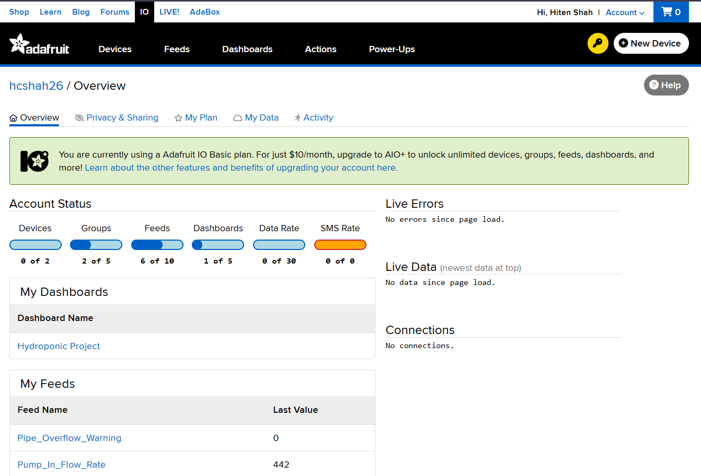

# Appendix B - Feeds Page

# Appendix C - Dashboard Page

Hydroponic Project Dashboard view – all key information is clearly presented and easy to interpret at a glance.

# Appendix D - Actions Page

Configuring an Action – Critical Water Level Warning

# Appendix E - Alerts Email

When an action is triggered, the Action will send a notification. In our case the Action was the Critical Water Level warning was triggered. The actions of this event is to send an email notification to inform of this critical water level issue that has taken place.

See below a copy of email.

Wokwi – Critical Water Level button pressed, you can see the Critical Water Level LED has come on, and the pump status LED has switched off. – This has protected the pump from burning out.

Adafruit Dashboard – We can very quickly see that the Reservoir Critical Indicator has been triggered and pump has been switched off.

